**ASSIGNMENT 1 FRONT SHEET**

|  |  |  |  |
| --- | --- | --- | --- |
| **Qualification** | **TEC Level 5 HND Diploma in Computing** | | |
| **Unit number and title** | **Unit 04: Database Design & Development** | | |
| **Submission date** |  | **Date Received 1st submission** |  |
| **Re-submission Date** |  | **Date Received 2nd submission** |  |
| **Student Name** | Bùi Hương Linh | **Student ID** | GBH200662 |
| **Class** | GCH1002 | **Assessor name** | Hàn Minh Phương |
| **Student declaration**  I certify that the assignment submission is entirely my own work and I fully understand the consequences of plagiarism. I understand that making a false declaration is a form of malpractice. | | | |
|  |  | **Student’s signature** |  |

**Grading grid**

|  |  |  |
| --- | --- | --- |
| P1 | M1 | D1 |
|  |  |  |

|  |  |  |
| --- | --- | --- |
| **❒ Summative Feedback: ❒ Resubmission Feedback:** | | |
| **Grade:** | **Assessor Signature:** | **Date:** |
| **Signature & Date:** | | |

Table of Contents

Chapter 1: Statement of user and system requirements 4

1. Overview about the problem 4

1.1 Business process 4

1.2 Business rules 4

1.3 Requirements 4

Chapter 2: Design the relational database system 5

1. Analyse the requiments 5

2. Database design with explanations 5

2.1. Logiscal design 5

2.2. Physical design 7

3. List of tables 8

4. Wireframe of the application 12

Table 1: Customer 8

Table 2: Staff 8

Table 3: Product 9

Table 4: Invoice 9

Table 5:InvoiceDetails 9

Chapter 1: Statement of user and system requirements

1. Overview about the problem

As we all know, currently in the business form market is gradually becoming popular and tends to develop strongly. Of course, it is also related to the increasing demand of consumers and the author's business is widely known. And the author wants to expand the business by expanding the space and diversifying accessories, books, ... to attract more customers. And the author's goal is to try to generate more sales each day than the day before. In your opinion, is it effective to use old technology to have a crowded store? The author has recruited a large IT consulting firm with expertise in database design for management systems to handle the above challenge. The database designer must establish the personal information of each customer and employee. Here employees can view both customer and product information. To build a suitable calculation database, the database designer should also set up a list of Products, prices, .. for employees and guests. And when the customer makes a purchase, there will be a detailed invoice. If customers want to sit and read, relax, there is a separate space for customers. All data will be handed over to the kernel and staff will execute and manipulate faster than technology.Requirements of the application

* 1. Business process

At the beginning of a working day, staff will check the goods and arrange them neatly before customers come to buy goods. There are 2 options for customers to buy directly or through the store's fanpage. but direct buying is very well received by people and business development will not be far away when the author has an easy to understand and quick sales management system..... sales management system very easy to understand and simple with staff. With a few moves, the staff knows the customer's name, where, ..... as well as the customer can see his information as well as product information.

* 1. Business rules

Staff need to correctly confirm the customer's identity

Confirm the correct product information that the customer has ordered.

Employees need to update product information daily to prevent changes.

Mention the product information and production area to the customer if the customer asks.

Only employees can access and view their own and everyone else's information.

* 1. Requirements

The system must be designed to be simple for the user to use.

Employees must know the information of all customers and products for easy management.

The system will support employees to enter information about products, customers, regions, .....

The system will allow customers to view product list, product information as well as price list.

The price of the product may change by month or year.

Chapter 2: Design the relational database system

1. Analyse the requiments

According to the author's wish, for future development, the author would like to expand the store's business model, because there are many different products and a large number of customers and employees. As a result, the author will create the database and divide the system's components so that he can manage them easily and save time.

First, customers and employees must enter personal information into the store system, such as their ID, name, phone number, address, gender, age, and so on. The system will read data and save it automatically, such as customer and employee personal information. Each individual will be assigned a unique id code. The primary key that allows for easy, accurate, and quick identity verification is id. And of course the staff will see product information such as: product code, product name, import price, ... Since a customer can buy many different things, a detailed invoice should be provided to avoid confusion. Information of the invoice details table includes: In_ID, Pro_ID, InD_Quantity, InD_Price, InD_Discount. Of course, it is indispensable for customer information every time they come to buy. Customer information includes: Customer_ID, Customer_Name, Customer_DoB, Customer_Phone, Customer_Address, Customer_Email, Customer_Workingday.

1. Database design with explanations
   1. Logiscal design

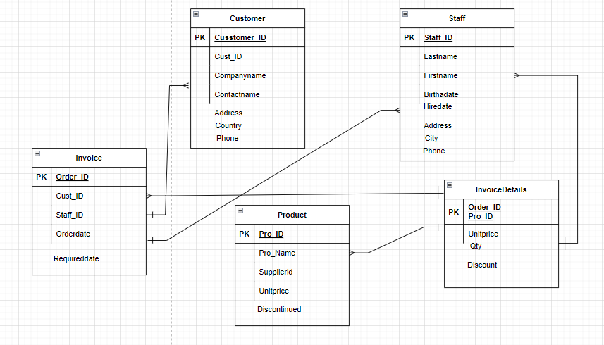

* 1. Physical design

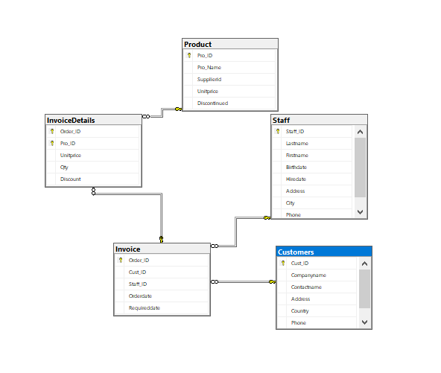

1. List of tables

|  |  |  |
| --- | --- | --- |
| Column Name | Data type | Allow null |
| Cust_ID | INT | NOT NULL |
| Companyname | NVARCHAR | NOT NULL |
| Contactname | NVARCHAR | NOT NULL |
| Address | NVARCHAR | NOT NULL |
| Contry | NVARCHAR | NOT NULL |
| Phone | NVARCHAR | NOT NULL |

Table 1: Customers

|  |  |  |
| --- | --- | --- |
| Column Name | Data type | Allow null |
| Staff_ID | NVARCHAR | NOT NULL |
| Lastname | NVARCHAR | NOT NULL |
| Firstname | NVARCHAR | NOT NULL |
| Birthdate | DATETIME | NOT NULL |
| Hiredate | DATETIME | NOT NULL |
| Address | NVARCHAR | NOT NULL |
| City | NVARCHAR | NOT NULL |
| Phone | NVARCHAR | NOT NULL |

Table 2: Staff

|  |  |  |
| --- | --- | --- |
| Column Name | Data type | Allow null |
| Pro_ID | NVARCHAR | NOT NULL |
| Pro_Name | NVARCHAR | NOT NULL |
| Supplierid | INT | NOT NULL |
| Unitprice | MONEY | NOT NULL |
| Discontinued | BIT | NOT NULL |

Table 3: Product

|  |  |  |
| --- | --- | --- |
| Column Name | Data type | Allow null |
| Order_ID | INT | NOT NULL |
| Cust_ID | INT | NOT NULL |
| Staff_ID | NVARCHAR | NOT NULL |
| Orderdate | DATETIME | NOT NULL |
| Requireddate | DATETIME | NOT NULL |

Table 4: Invoice

|  |  |  |
| --- | --- | --- |
| Column Name | Data type | Allow null |
| Order_ID | INT | NOT NULL |
| Pro_ID | NVARCHAR | NOT NULL |
| Unitprice | MONEY | NOT NULL |
| Qty | SMALLINT | NOT NULL |
| Discount | NUMERIC | NOT NULL |

Table 5:InvoiceDetails

Customer

|  |  |  |  |  |  |
| --- | --- | --- | --- | --- | --- |
| Customer_ID | Customer_Name | Customer_DoB | Customer_Phone | Customer_Address | Customer_Email |
| C1 | Bùi Hương Linh | 08/08/2002 | 0972208243 | Tan Lap-Dan Phuong-Ha Noi | linhhuong8802@gmail.com |
| C2 | Bùi Doãn Quân | 19/03/2004 | 0988257208 | Tan Lap-Dan Phuong-Ha Noi | quanbui1903@gmail.com |
| C3 | Bùi Thị Liễu | 16/03/1993 | 0977169693 | Dong Thap-Dan Phuong-Ha Noi | [lieubui1603@gmail.com](mailto:lieubui1603@gmail.com) |
| C4 | Bùi Thị Thúy | 25/07/1995 | 0988325795 | Tan Lap-Dan Phuong-Ha Noi | buithuy2507@gmail.com |
| C5 | Bùi Doãn Dũng | 15/09/1998 | 0972435169 | Tan Lap-Dan Phuong-Ha Noi | buidung1509@gmail.com |

Staff

|  |  |  |  |  |  |  |
| --- | --- | --- | --- | --- | --- | --- |
| Staff_ID | Staff_Name | Staff_DoB | Staff_Phone | Staff_Address | Staff_Email | Staff_Workingday |
| ST1 | Nguyễn Văn Hòa | 14/01/2002 | 0974562581 | Doan Hung- Phu Tho | hoanguyen1401@gmail.com | 05/03/2020 |
| ST2 | Phùng Quốc Việt | 28/02/2002 | 0367541523 | Pham Van Bach- Cau Giay- Ha Noi | quocviet2802@gmail.com | 25/12/2019 |
| ST3 | Nguyễn Phương Thảo | 02/05/2002 | 0962208499 | Long Bien- Ha Noi | thaonguyen0205@gmail.com | 05/08/2019 |
| ST4 | Nguyễn Thanh Chúc | 20/07/2000 | 0918590378 | 130 Xuan Thuy- Cau Giay- Ha Noi | thanhchuc2007@gmail.com | 28/08/2019 |
| ST5 | Ngô Thanh Vân | 11/12/1998 | 0913758498 | Chua Lang- Lang Thuong- Dong Da- Ha Noi | thanhvan1112@gmail.com | 11/09/2019 |

Product

|  |  |  |  |  |
| --- | --- | --- | --- | --- |
| Pro_ID | Pro_Name | Pro_Country | Pro_Unit | Pro_Price |
| TK1 | Pencil | Trung Quoc | cai | 5500 |
| TK3 | Pencil | Lao | cai | 11000 |
| B6 | Book | Indo | quyen | 54510 |
| B8 | Book | Campuchia | quyen | 142500 |
| NB2 | Notebook | Viet Nam | quyen | 12000 |
| NB1 | Notebook | Thai Lan | quyen | 51100 |

Invoice

|  |  |  |  |
| --- | --- | --- | --- |
| In_ID | In_Date | Customer_ID | Staff_ID |
| 1 | 23/01/2022 | C2 | ST1 |
| 2 | 20/04/2022 | C2 | ST1 |
| 3 | 04/02/2022 | C3 | ST3 |
| 4 | 02/01/2022 | C3 | ST3 |
| 5 | 05/11/2021 | C4 | ST2 |

InvoiceDetails

|  |  |  |  |  |
| --- | --- | --- | --- | --- |
| In_ID | Pro_ID | InD_Quantity | InD_Price | InD_Discount |
| 1 | TK1 | 10 | 320000 | 0 |
| 1 | TK3 | 15 | 250000 | 1 |
| 2 | B1 | 3 | 650000 | 0 |
| 3 | NB8 | 10 | 280000 | 0 |
| 4 | B4 | 5 | 920000 | 0 |

1. Wireframe of the application

